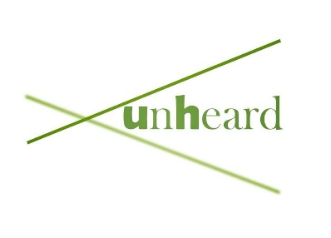
Creatives Contract – voice recording
(if editing online please type your answers in red)

Please write your name and preferred pronouns:
Name:-
Pronoun:-

Would you like to be credited for your work or would you prefer to be kept anonymous? (please highlight)
- Anonymous
- Accreditation

If you would like credit what is your preferred name to be credited as?
-
Do you have an Instagram/Twitter tag you would be happy for us to use? Please put all answers below:
-
What is your preferred means of contact? (i.e. Email/Instagram)
-

Please confirm that you are you happy for us to use your work, with full accreditation in the way you have specified, to be edited into a poem track with other voices by the sound designer of the project. (please highlight)
- Yes
- No

Please confirm that you will not share the work as your own, or share it before Unheard has published it
- Yes
- No

Are you happy for us to republish your work in the future with the same project and in the same form it will be published this first time around? For example, as a rerun. Your work will always be credited in your preferred ways.
- Yes
- No

By signing you agree that we have the power to use your work in the above mentioned ways only.

Please sign here:
-
Date signed:
-

If you have any further queries please do not hesitate to contact us via email at
poetryunheard@gmail.com

Our GDPR can be found on our website on the “contact” page

